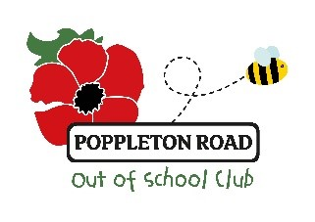
OFSTED REGISTRATION NUMBER 543552
Charity number 1157546
c/o The Annexe, Poppleton Road Primary School,
Poppleton Road, York, YO26 4UP
Mob: 07713435506
Email: poppyroadkidsclub@hotmail.co.uk
Children’s registration form
Please complete one form per child
Childs Details
Child’s Full Name:
Child Likes to be Known As:
Date of Birth: |  | Age:
School/Setting Child Attends |  | Ethnicity/Religion  Languages Spoken
Address:

Post Code:
Additional Needs/Dietary Requirements:

Parent/Carer Information
Parent/Carer Name One |  | Parent/Carer Name Two
Address (if different from above)  Post Code: |  | Address (if different from above)  Post Code:
Contact Number: |  | Contact Number
Work Number: |  | Work Number:
Email Address: |  | Email Address
Does this person hold parental responsibility? |  | Does this person hold parental responsibility?

By signing this form, you agree that the information detailed on this form is correct, and that you and your child abide to the setting’s policies and procedures (Available on our website - https://www.poppyroadkidsclub.co.uk/). As well as updating the setting if any of the details on this form change.

By signing this form, you also agree to the settings confidentiality procedure. A copy may be provided on request.

Signed ……………… ……………………………………………. (Parent / Carer) Date:…………………………………

